Bocce 101

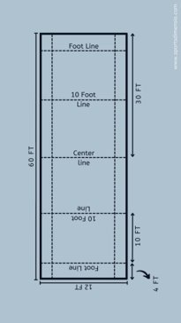
- 9 balls (4 red, 4 blue and 1 white ball called the pallina)​
- Coin toss determines who starts first ​
- Game starts by throwing the pallina and then the first ball (the in ball)​
- All balls must be thrown below the waist​
- The pallina must land between the center line and the opposite 10-foot service line. ​
- They will then throw their first ball ​
- The opposing team throws until they are the next in ball​
- After frame 1 players will switch ends. ​
- Whoever won the last frame gets possession in the new frame The Game will continue until 12 points is reach or 20 mins - last frame finishes ​
- Points are awarded based on how close your team’s balls are to the pallina​
- 1 point awarded if you have the closest ball​
- 2 points awarded if you have the 2 closest balls​
- 3 points awarded if you have the 3 closest balls​
- 4 points awarded if you have the 4 closets balls​

Bocce Video Guide: https://www.youtube.com/watch?v=d7-VJmgBZ_U
- Please note there may be some discrepancies

Roles​
​

Head Official ​
​
Responsibilities: ​
- Coin Flip ​
- Measuring distances from the balls to the pallina​
- Show the colour of what team is going next with the ping pong paddle​
- Facilitating Sequence of play ​
- Showing the scoretable the score after each frame ​
​

Lines Official​
​
Responsibilities: ​
- Judging whether the pallina is in play​
- Placement of the pallina at the center if needed ​
- Ensuring the thrower does not cross the service line​
- If a ball goes out of the court place it back where it left the court 1 foot from the line ​
- Correct any illegal roles of the ball (rolling out of turn)​
- Keeps track of the time – announces final frame ​

