5 Pin / Tenpin Bowling Host Package
APPENDICES

Table of Contents
Appendix K Competition Committee 3
Competition Host 3
Volunteer Coordinator 3
Fundraiser 3
Registration Coordinator 4
Meals Coordinator (if applicable) 4
Public Relations 5
Appendix L Competition Invitation 6
Appendix M Registration Form 7
Appendix N Booking Officials 9
Appendix O Venue Set Up 10
Appendix P Divisioning/ Results 11
Appendix Q Sample Agenda 13
Appendix R Supplies Check List 14

Appendix K
Competition Committee

Running a competition can be a large undertaking and it helps to have a group of people helping to share the work. The following outlines the recommended division of labour.

Competition Host
Facility: You will need use of a bowling centre and a place for athletes to eat. A place to do the data inputting (small room with two outlets) is required for Provincial Qualifiers and suggested for any event using divisioning.
Coaches Meeting: It is your responsibility to hold a coaches meeting prior to the start of the tournament. You will go over the rules of the competition and the schedule of events and answer any questions the coaches may have.
Competition Budget: Work with the Fundraising and Meal committee members to determine the competition budget. Athlete registration fee is not to exceed $25 per player. Communities can apply for an SOO competition grant to offset a projected deficit. Budgets should be submitted to SOO staff 4 weeks prior to a competition.
The day of the meet it is up to the Competition Host to ensure that everything is running smoothly.
Note: often the competition host takes on one or more of the roles outlined below

Volunteer Coordinator
Meal Volunteers (if needed): Check with the committee member in charge of the meal to find out how many helpers they would like to work with them to sort the meals into team boxes (normally 2-3 helpers would be good).
Team Ambassadors: If you have additional volunteers, they can be assigned to individual teams, to act as runners, cheerleaders and support.
The day of the meet it is your responsibility to sign in all of your volunteers and provide orientation to what is expected of them for the day. You should provide your volunteers with t-shirts and have certificates or letters of thanks for all of your volunteers, but especially the ones that are helping for their volunteer hours.

Fundraiser
Lane sponsorships: You can try to get lane sponsors and you can use whatever you would like as your benchmark ($100 for bronze, $150 for silver and $200 for gold as an example). Make sure that they send you a logo or sign that you can put up at their designated lanes.
Program Sales: The program is a tool marketed towards the spectators. They can include schedules, participating team rosters, sponsor information, rules etc. Cost will vary depending on cost to produce.
Inform visiting teams ahead of time that programs are only provided free of charge to the teams.
Food Donations: It is always a good idea to try to get as much of the food donated as possible. So work with the meal coordinator to determine what food they are looking for and help that committee member draft and distribute a donation letter to local grocery stores (you can normally get your fruit and drinks for free).
Bake Sale: Many competitions run successful bake sales to help raise funds. Make sure you advertise the bake sale ahead of time to all attending teams and your local spectators to maximize the fundraising potential.
Day of Duties: The day of the meet you need to make sure that your lane sponsor’s signs are displayed appropriately. After the event, send out a thank you card to all of your sponsors with a picture of athletes from the meet.

Registration Coordinator
Registration Package: Work with the competition host to put together the registration package and send it out to all invited clubs. Receive all registrations and disseminate the information to other committee members as needed.
Numbers: Provide final numbers of athletes and teams to all other committee members when the registration packages have been returned.
Registration Packages: You will man the registration table the day of the event, collecting any outstanding entrance fees and giving teams their registration packages, which should consist of a schedule, SOC rules, list of key event volunteers, and spectator code of conduct).

Meals Coordinator (if applicable)
Meals: Decide what you would like to provide the athletes for their meal and work with the Fundraiser to get as much of the meal donated as possible. Ensure accurate numbers are given to the supplier of the food and either pick up the food or confirm delivery. Work with the registration coordinator to determine and provide for any food allergies.
Snacks: Water should be available for all participants and volunteers. You can also look at providing juice to your volunteers throughout the competition. Some hosts also provide cut up fruit to the athletes halfway through the competition. Work with the Volunteer Coordinator to ensure there are volunteers available to help with any distribution of juice or snacks to the officials and participants throughout the meet.
The day of the event it is your job to make sure all of the food has been delivered and to sort the food into team boxes (let the Volunteer Coordinator know how many helpers you would like for this task).

Public Relations
It is your job to alert the local media that the tournament is occurring and then be present at the venue during the day to answer any questions for any media that do attend.

Appendix L
Competition Invitation

Bowling “5 & 10 Pin” Invitational
Date: Competition Date
Where: Location, including street address
Time: Registration 8:15 a.m.
Games begin at 9:00 a.m. (continuing through until approximately 5:00 p.m.)
Cost: $25 per athlete
Rosters: (Information pertaining to club rosters) Only athletes and coaches registered with SOO are permitted to participate.
Lunch: Applicable information
Rules: SOC Bowling Rules will apply.
Tournament Format: Scratch or Handicap or POA (Provincial Qualifier will always be Scratch)

Registration Deadline: DATE
The following must be received on or before (registration deadline).
- Entry fee cheque (made payable to SOO Community)
- Team contact information (i.e. names, phone numbers (home & cell), e-mail addresses of coaches).
- List of Participants (including: Name, SOO Number, Current League Average) (See Appendix E)
Please forward registrations to: SOO – Community
Address
Address
Postal Code
Inquiries: (Competition Host) – (phone), (e-mail)
Space is limited so register early to ensure acceptance!

Appendix M

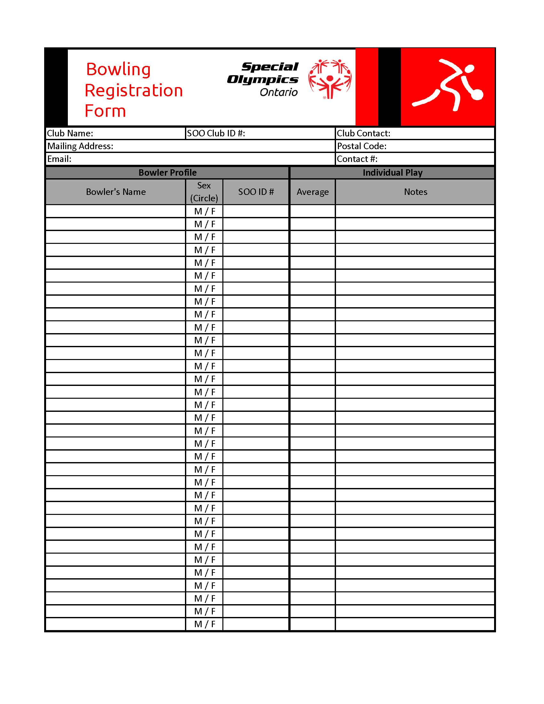
Registration Form

Special Olympics Ontario
Five and Ten Pin Bowling – League Record Sheet
This form should be completed by the coach if the Bowling Centre is not able to provide a computerized print out of the League Record Sheet.
Athlete Name: Gender: District:
Club Name: Community:
Team: Previous Year Average:

Date | 1st Game | 2nd Game | 3rd Game | Three Game Total | Total Pinfall | Total Games | AVG.
Five Pin Bowling: Athletes must have a minimum of 25 games bowled by May 1st of qualifying year to be eligible to advance to Provincial games and National Games.
Ten Pin Bowling: Athletes must have a minimum of 30 games bowled by May 1st of qualifying year to be eligible to advance to Provincial Games and National Games.
League Record Sheets must be completed for all athletes advancing to Provincial and National Games.

Appendix N
Booking Officials
Primary Officials
- Judge of Play
Qualifications
- 5 & 10 Pin: Experience acting as a Judge of Play and/or an official at 5 Pin Bowling Tournaments - Generic or Special Olympics.
Responsibilities
- Responsible for recruiting and training all scorekeepers, lane monitors and results volunteers
- Serve as the lead of the Sport Rules
- Responsible for ensuring that the tournament is run in accordance with the official rules of Special Olympics Canada and the associated National Sport Federation, (5 Pin - C5PBA, Tenpin – CTF).
Secondary Officials
- Scorers (1 per lane)
Qualifications
- Experience scorekeeping at Bowling Tournaments - Generic or Special Olympics
Responsibilities
- Responsible for recording the score for the lane in which they are stationed

- Lane Monitors (1 per lane)
Qualifications
- Experience officiating at Bowling Tournaments - Generic or Special Olympics
Responsibilities
- Responsible for monitoring play on the lane in which they are stationed
- Ensure bowlers are bowling in the correct order
- Responsible for notifying the Head Official should a violation occur

- Results Coordinator (number depending on the size of tournament)
Qualifications
- Experience scorekeeping at Bowling Tournaments - Generic or Special Olympics
Responsibilities
- Responsible for verifying game scores and the posting of results, unofficial and official

Appendix O
Venue Set Up

Appendix P
Divisioning/ Results

When determining Divisions for an Invitational Tournaments you want to work through the following steps:
- Use Excel to sort athletes from Lowest Average to Highest Average
- Ensure a minimum of 3, maximum of 8 athletes per division
  - For Invitational Tournaments the recommendation is 6 athletes per division
- Athletes with the same average need to be kept in the same division
- Wherever possible, there shouldn’t be more than a 25% differential between averages in the same division
  - Take the highest average in the division and multiply it my 0.75; the lowest average in the division should not exceed this number

When determining Divisions for a Provincial Qualifier you want to work through the following steps:
- Separate athletes by Gender
**The remaining steps need to be done separately for each gender**
- Use Excel to sort athletes from Lowers Average to Highest Average
- Ensure you have a minimum of 3, maximum of 8 athletes per division (Start with the highest average and work towards the lowest average)
  - For a Provincial Qualifier, you want as many divisions of 8 as possible
- Athletes with the same average need to be kept in the same division
- Wherever possible, there shouldn’t be more than a 25% differential between averages in the same division
  - Take the highest average in the division and multiply it by 0.75; the lowest average in the division should not exceed this number
  - For the Lowest Division this may not be achievable, there needs to be a minimum of 3 athletes in a division and this could exceed 25%

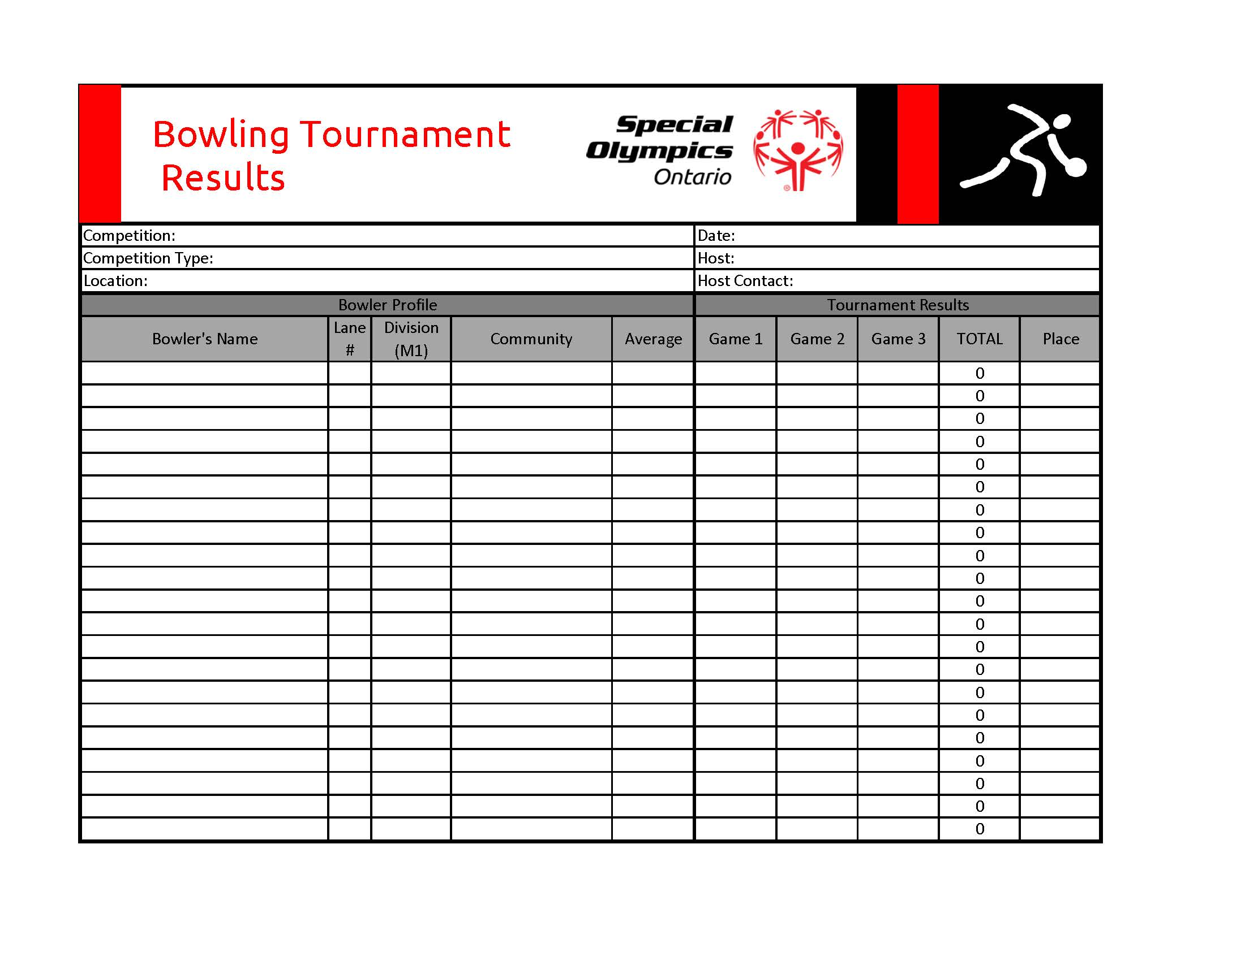

Appendix Q
Sample Agenda

Pre Competition Preparation
- Competition Host create final draft of tournament schedule
- Request help from 3-4 volunteers as needed

Committee arrival for Set Up 7:30 a.m.
- 3 to set up volunteer room/statistics room
- 3 to set up volunteer check in/registration: t-shirts, volunteer forms and name tags

Competition Volunteers Arrival 8:15 a.m.
- Directed to volunteer room to drop of stuff, pick up t-shirts, name tags and fill out volunteer forms
Team Arrival & Registration 8:15 a.m.
- Teams are directed to the change rooms, coaches to sign in at the registration table and pick up packages
- As spectators arrive they are to be informed about the spectator seating
Team Warm Ups Begin 8:30 a.m.
- Teams can utilize the lane space to stretch and warm-up.
Registration Table Closes 8:45 a.m.
- Volunteer to bring scratches and money box to statistics room
Coaches Meeting 8:45 a.m.
- Held by the Competition Host
Warm Up Complete 9:00 a.m.
Opening Ceremonies 9:02 a.m.
- Athletes to parade in by teams and lead onto field by volunteer
- Choose a athletes to perform Athletes Oath
First Ball is thrown 9:15 a.m.
Pick up Lunch 11:00 a.m.
- Volunteer to pick up and 2-3 volunteers to sort as needed
Serve Lunch 11:30 a.m.
- Volunteer to deliver to each team
End of Competition 3:00 p.m.
- Volunteer or sponsor to hand out ribbons

Tear Down 3:05 p.m.
- Volunteers to pick up personal items from stats room and are free to leave THANK YOU

Appendix R
Supplies Check List

Things you will need:
□ Computer and printer (For PQ's to print results)
□ Printer paper
□ Ribbons
□ Bowling Balls (provided by centre)
□ Bowling Shoes (provided by centre)
□ Scoresheets (one per division)
□ Calculators (1 per lane)
□ Towels (1 per lane)
□ Water Station
□ PA System – Generally your venue will have, but confirm prior to the event

