
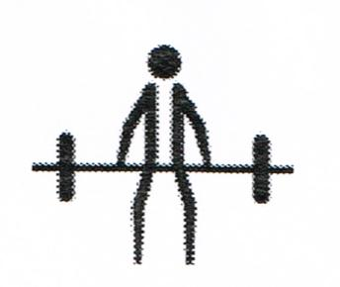

INVITATIONAL
3-LIFT
POWERLIFTING COMPETITION
SATURDAY, MAY 30th, 2026
8:00 – 5:00

Sponsors: Special Olympics Ontario London

Ontario Police College
10716 Hacienda Rd, Aylmer, ON (Malahide Township)
Squat. Bench Press & Deadlift
COST: $25.00 per athlete
Attach cheque with registration form:

DEADLINE FOR REGISTRATION:
May 10th, 2026

Weigh in & Equipment check from 8:00 – 8:30
Lunch will be provided at the venue for all athletes & coaches
Please note any special dietary requests.

QUESTIONS?
Phone Rick Walker 519-860-7236
mailto: rickwalker@rogers.com

S.O.O. POWERLIFTING INVITATIONAL
COMPETITION
SATURDAY, MAY 30, 2026
ATHLETE REGISTRATION

COMMUNITY NAME

CONTACT NAME email address: .

EMERGENCY PHONE NUMBER IN CASE OF CANCELLATION ETC

 | ATHLETE NAME | ATHLETE WEIGHT  (KGS) | O.S.O. REG # | 2-lift or 3-lift | MALE/  FEMALE
1
2
3
4
5
6
7
8
9
10
 | COACHES |  | O.S.O. REG#
1
2
3

*ANY athlete without proper SOO registration number cannot and will not be allowed to participate.

Please forward this amount with this form. Thank you.

DEADLINE IS May 10th, 2026
PAYMENT TO:
Special Olympics Ontario London
P.O. Box 918 Stn B
London, Ontario, N6A 4Z3

Ontario Police College

The Ontario Police College (OPC) is located at 10716 Hacienda Rd, in Malahide Township (suburb of the town of Aylmer). Once you have entered the OPC grounds, there is a parking lot on the right side. Participants and visitors will report to the front desk for admission.

