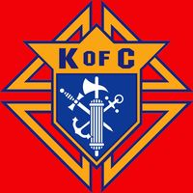
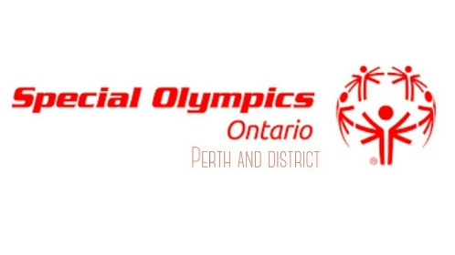
Special Olympics Ontario
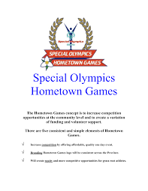
Hometown Games

PRESENTS
The 16th Annual Special Olympics Soccer Tournament
Hosted by: Knights of Columbus
District 30
When: Saturday August 9th, 2025
Where: Conlon Farm Soccer Fields, 127 Smith Dr., Perth Ontario
Cost: $10.00 per athlete
Time: 8:00am-4:00pm
Lunch: Provided free for athletes and coaches
Important:
- Registration Deadline: July 26th, 2024
- Please refer to the Sport Technical Package for Soccer for the rules

To register, please email completed form to: amanda.mitchell2011@hotmail.com
Please make cheques out to: Perth and District Special Olympics
Mail Cheques to: Tracy Majaury
117 Arnold Drive, Perth ON K7H 0H4
Due the latest August 1st, 2025

Schedule of Events

8:15am Opening Ceremony
9:00am Competition
12:00pm Lunch
1:00pm Competition
3:45pm Closing Ceremony

Please remember to bring sunscreen, a hat, sports equipment, and a reusable water bottle!

For additional information regarding the schedule of events please contact:
Pat Loftus- Knights of Columbus Email- pat.loftus@kingston.net or 613-267-6303

The 16th Annual Special Olympics Soccer Tournament

Please refer to SOC Soccer Rules and FIFA Soccer Rules for competition rules.

TEAM ROSTER
Team Name: |  |  | Skill Level:
Team Colours:
Head Coach Name:  SOO#: |  |  |  | Phone:  Email:
Assistant Coach Name: SOO#:
Assistant Coach Name: SOO#:
 | Athlete Name | Jersey # |  | SOO# | Dietary Restrictions
1
2
3
4
5
6
7
8
9
10
11
12
13
14
Head Coach Signature:

