

LONDON OPEN GOLF TOURNAMENT
Team “Best Ball” Play – Par 27
LONDON, ONTARIO
SATURDAY, AUGUST 9th, 2025
11:30 – 3:00
Sponsors: Special Olympics Ontario- London
Parkside 9 Golf Course
Situated near intersection of
2305 Fanshawe Park Road East
Fanshawe Park Road & Clarke Side Road
This is a par 27 course designed for beginner golfers
Best ball format in team play

see map
COST: $10 PER ATHLETE
Let us know how many coaches are coming!!
You can bring cheque to tournament:

DEADLINE FOR REGISTRATION:
JULY 28th, 2025

Schedule to follow registration.
Lunch, water & healthy snacks will be provided.

Contact: Rick Walker 519-860-7236 rickwalker@rogers.com

S.O.O. Invitational Golf Tournament
SATURDAY, AUGUST 9th, 2025
ROSTER

COMMUNITY:

SKILL LEVEL This is NOT a tournament for athletes with above average skills. This tournament is designed for athletes whose skill sets are very basic/novice.
CONTACT NAME
EMERGENCY PHONE NUMBER IN CASE OF CANCELLATION ETC

Team Name:
Head Coach: |  |  |  |  | SOO #:
Phone: |  |  | Fax:
Email address:
Mailing address:
City: |  |  |  | Postal Code:
Assistant Head Coach: |  |  |  |  | SOO #:
Athletes  4 players required per team. We can pair your athletes with other athletes from other communities |  | Athlete Name: |  |  | SOO #:
 | 1
 | 2
 | 3
 | 4
 | 5
 | 6
 | 7
 | 8
 | 9
 | 10
# of coaches attending

- ANY athlete without a proper SOO registration number cannot and will not be allowed to participate.

Please forward this amount with this form. Thank you.

DEADLINE IS JULY 28th, 2024
RETURN TO: Rick Walker 519-860-7236
rickwalker@rogers.com
c/o SOO London – P.O. Box 918 Stn B London, Ontario N6A 4Z3

Parkside 9 Golf Course
Intersection of Fanshawe Park Road & Clarke Side Road
GPS – 2305 Fanshawe Park Road East
Northeast London
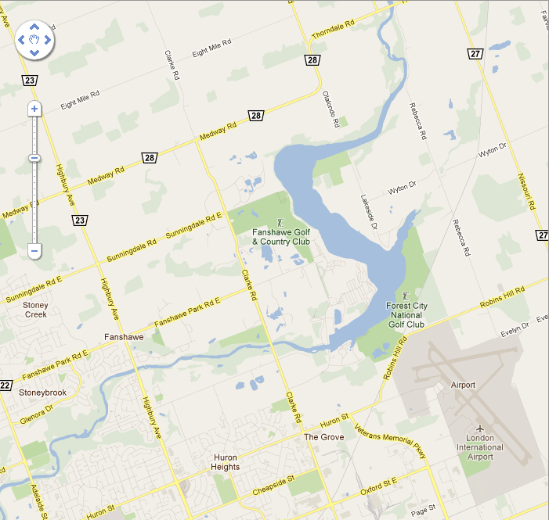

Directions to Parkside 9 Golf Course (is part of Fanshawe Golf Course but different entrance)
- Is situated in Northeast part of city
- Come to intersection of Fanshawe Park Road & Clarke Side Road
- Proceed east on Fanshawe Park Road about 100 metres, entrance is on the north side of Fanshawe Park Road



Basic Rules for the London
Open Golf Tournament
The Parkside 9 (par 27 – best ball)

Competition:

- Depending on the number of registered golfers, it is anticipated that there will be a shotgun start at noon. Be there early enough at 11:15, so that every player starts ON TIME!! You need to give yourself enough time to participate in the putting contest and then get to your starting hole.

- This is a best-ball format.

- Athletes must be able to make contact with the ball – whiffs allowed

- This is a short par 27 course – takes about 2 hours to play. There will be a putting contest.

- A limited number of pull carts are available at the golf course. Athletes are strongly encouraged to bring their own pull carts

- Power carts are not available to the athletes. A power cart will be available to the First Aider and the tournament organizer.

- At least one volunteer (two would be ideal) or coach will accompany each foursome to act:

  - As scorekeeper;
  - To assist with location of yardage markers;
  - ensure safe play;
  - ensure pace of play.

- The athletes are expected to transport their own clubs and give as much advice as they want to each other. Coaches and volunteers are free to caddy, coach and cheer to their hearts’ content

- Lunch will be provided to athletes. Likely sub sandwiches from either Tim Horton’s or Sobey’s. If there are any dietary issues, please let us know. If you have any food allergies, it is likely best that you bring your own food. We do have a refrigerator on site so we can store items for you.

